LADY HAWKINS’ SCHOOL

KINGTON HEREFORDSHIRE HR5 3AR

Headteacher: Mr J Kay Tel. (01544) 230441 Fax: (01544) 230978 Email: enquiries@lhs.hereford.sch.uk

Founded
1632
& SIXTH FORM

To The relevant Assessor

Thank you very much for helping the participant with their award. Success needs to be verified so please would you complete the form below to help the participant claim their award.

Points to cover:
Dates – The activity start date cannot be before the date the participant joined the award scheme
Dates – Bronze: the minimum spread for dates is 3 months, but 6 months is needed for 1 section
Silver: the minimum spread for dates is 6 months, but 12 months is needed for 1 section
Gold: the minimum spread for dates is 12 months, but 18 months is needed for 1 section
Time – Please comment that the participant has given up their free time to do the activity
Progress – Please comment on the progress made in activity related skills and knowledge during their participation
Success – Please comment on any successes e.g. products made, prizes/trophies won etc.

Thank you for your time and support, without your help students would not have the opportunity to participate.

Gary I House

Gary I House
Duke of Edinburgh’s Award Manager

Duke of Edinburgh’s Award Evidence form.
Name of Participant: DofE ID number:
Assessor – please complete the sections below.
This will be part of the evidence base to decide if the participant has passed their award
Award level: Bronze, Silver or Gold [delete as applicable]
Section: Physical, Skill or Volunteering [delete as applicable]
Activity:

Date started: | Date completed:
Total time: months. This is important; the dates above must show that the correct time has spent on this activity.

Assessor: | Role/Qualification:
Goals set:

Participants comments:

Assessors Comments:

Assessors signature: |  | Date:
Leaders signature: |  | Date:
Participant -Please scan/photograph the table from this sheet and upload it to your eDofe page as evidence of your success.






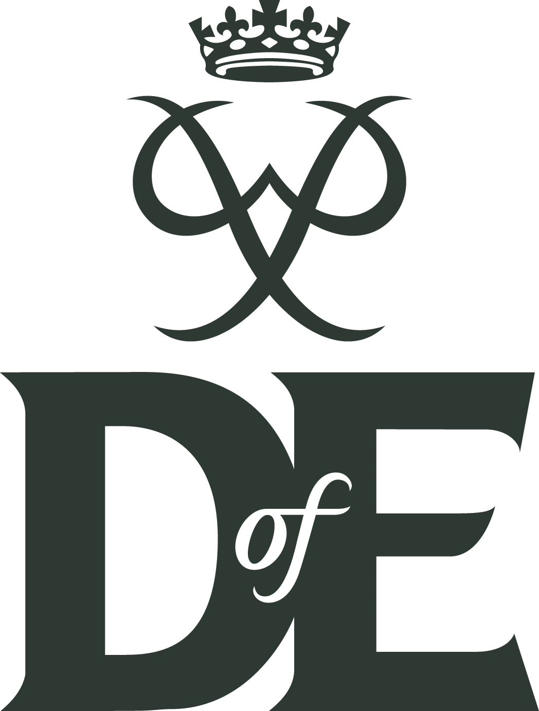
Lady Hawkins’ School and Sixth Form (Charitable Trust)
Registered in England and Wales
Company Number: 7722445
Registered office: Park View, Kington, Herefordshire. HR5 3AR

